BFAST - Fazenda Tanguro

#### ***Ana Carolina***

#### ***4 de abril de 2017***

Bibliotecas utilizadas

library(bfast)  
library(tseries)  
library(DBEST)  
library(strucchange)

## Loading required package: zoo

##   
## Attaching package: 'zoo'

## The following objects are masked from 'package:base':  
##   
## as.Date, as.Date.numeric

## Loading required package: sandwich

Organização dos pontos

setwd("C:\\Users\\ana.andrade\\ownCloud\\series_temporais_tanguro\\csv")  
arquivos2=dir()  
arquivos=arquivos2[3:length(arquivos2)]  
#Lista com todos os csv  
pixels=list()  
for(i in 1:length(arquivos)){  
   
 pixels[[i]]=read.csv(file= arquivos[i], header = T)  
   
}  
  
  
  
  
#Lista com todos os pontos  
ts=list()  
a=1  
for (j in 1:length(arquivos)){  
for(i in 1:9){  
   
 ts[[a]]=ts(as.numeric(pixels[[j]][i,4:395]), start= 2000.49, frequency = 23)  
 a=a+1  
}  
}  
  
#Retirar NA's  
i=1  
a=1  
b=1  
K=1  
for(i in 1:length(ts)){  
   
for(j in 1:392){  
 if(is.na(ts[[i]][j])){  
 if(is.na(ts[[i]][j-1])){  
 a=2  
 }else(a=1)  
 if(is.na(ts[[i]][j+1])){  
 b=2  
 }else(b=1)  
 ts[[i]][j]=mean(ts[[i]][j-a],ts[[i]][j+b])  
 } else(K=K+1)  
}  
}

Alguns estudos de caso

#Titulos  
#titulos=c(rep("Seringa",9), rep("Floresta-Floresta",9), rep("Floresta-Floresta",9), rep("Pastagem-Soja",9), rep("Eucalipto",9), rep("Eucalipto",9), rep("Pastagem-Soja",9), rep("Floresta-Floresta",9), rep("Floresta-Floresta",9), rep("Pastagem-Soja e Milho",9), rep("Pastagem-Soja e Milho",9), rep("Seringa",9), rep("Seringa",9))  
  
#k=c(rep(1,9),rep(2,9),rep(3,9),rep(4,9),rep(5,9),rep(6,9),  
 # rep(7,9),rep(8,9),rep(9,9),rep(10,9),rep(11,9),rep(12,9),rep(13,9))  
#g=rep(1:9,13)  
  
#for(i in 1:(length(arquivos)*9)){  
 # bb=bfast(ts[[i]], season = "harmonic", max.iter = 1)  
   
 #t=paste0("Ponto ", substr(arquivos[k[i]], 15,19),".",g[i],": ",titulos[i])  
 #plot(bb, main=t)  
   
 #}  
  
bb=bfast(ts[[68]], season = "harmonic", max.iter = 1)  
plot(bb, main="Pixel 24453: Floresta-Floresta")

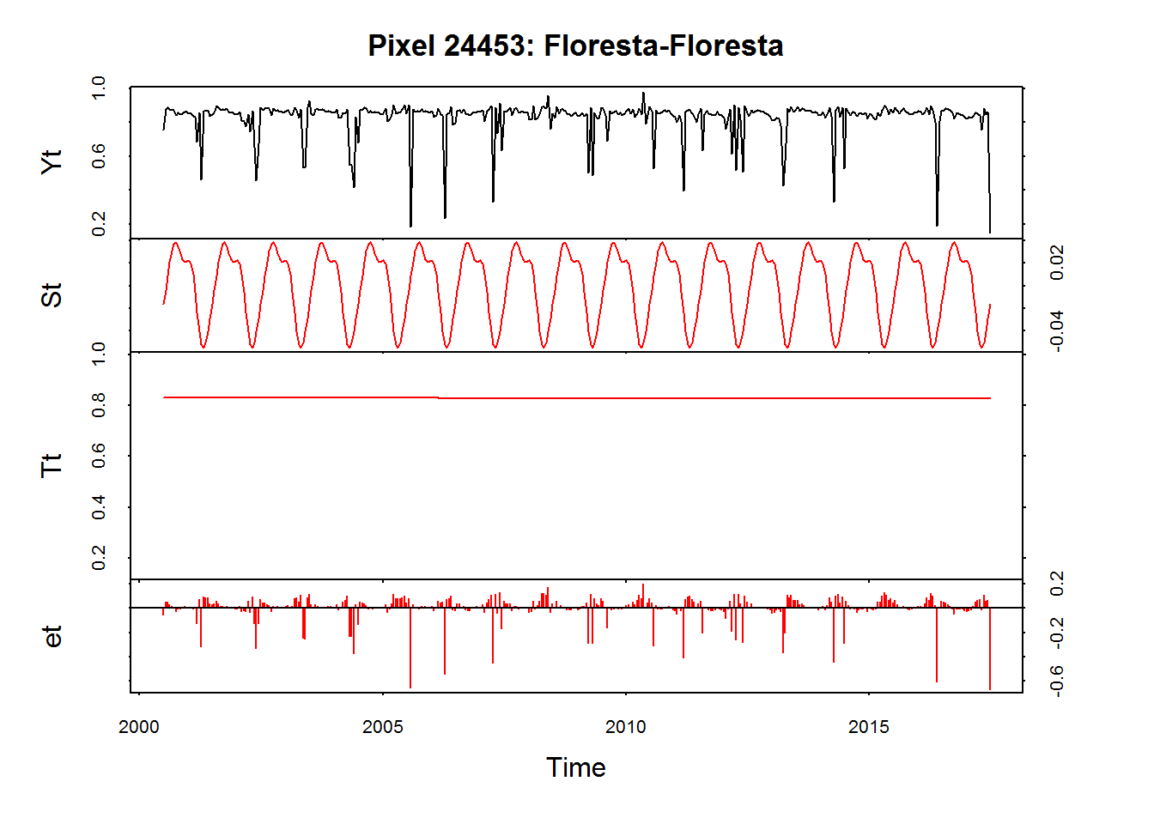

fs.nile <- Fstats(ts[[68]] ~ 1)  
plot(fs.nile)  
xx=breakpoints(fs.nile)  
n=length(xx$breakpoints)  
lines(breakpoints(fs.nile))

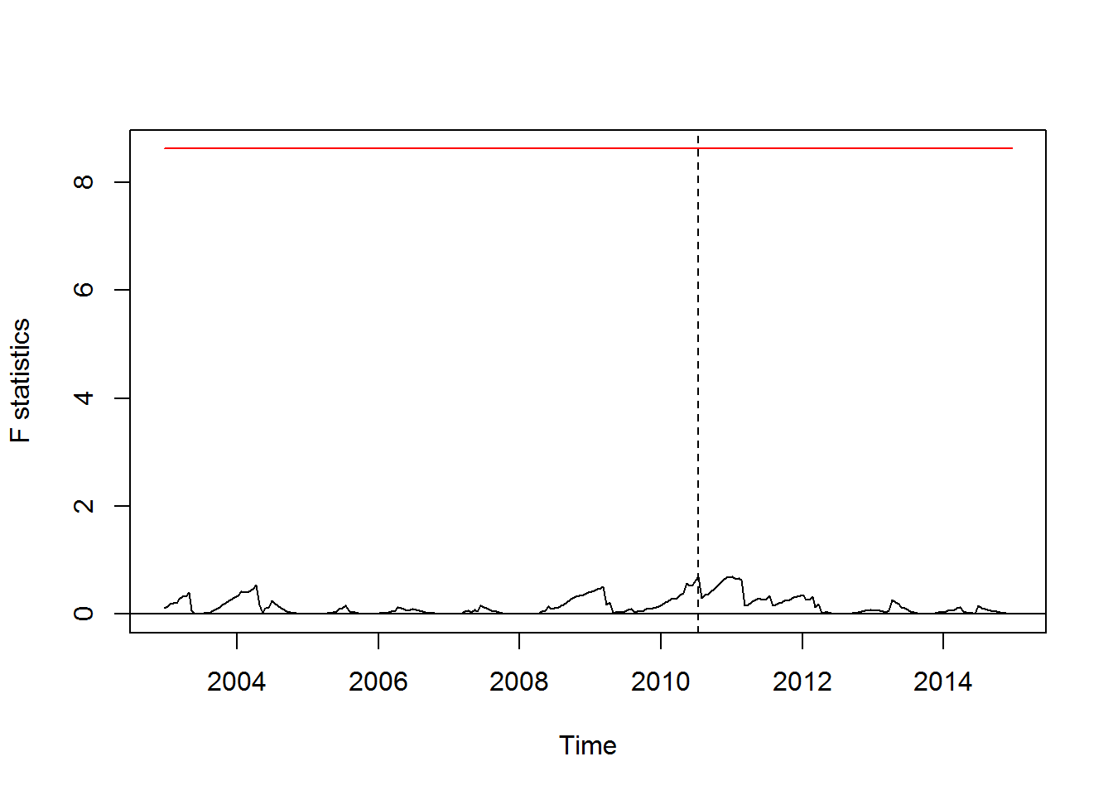

DBEST.Fig5a <- DBEST(data=ts[[68]], data.type="cyclical",   
 seasonality=23, algorithm="change detection",   
 breakpoints.no=n, first.level.shift=0.1,   
 second.level.shift=0.2, duration=24,   
 distance.threshold="default", alpha=0.05, plot="on")

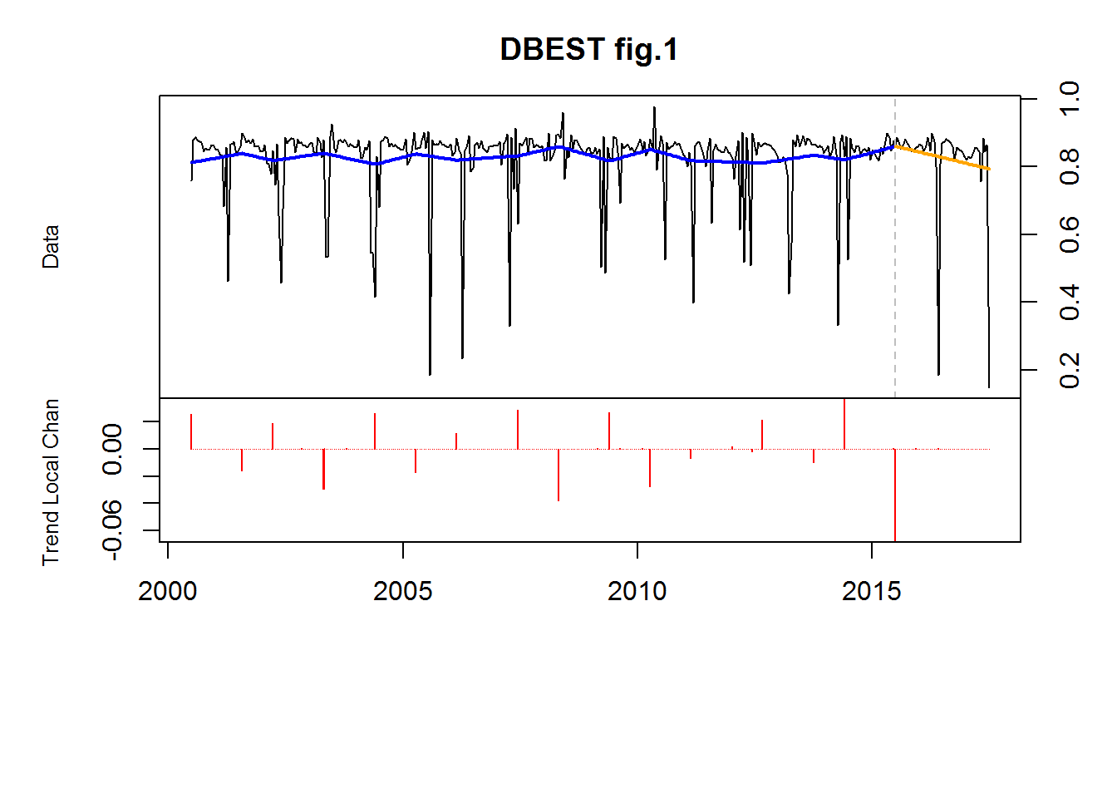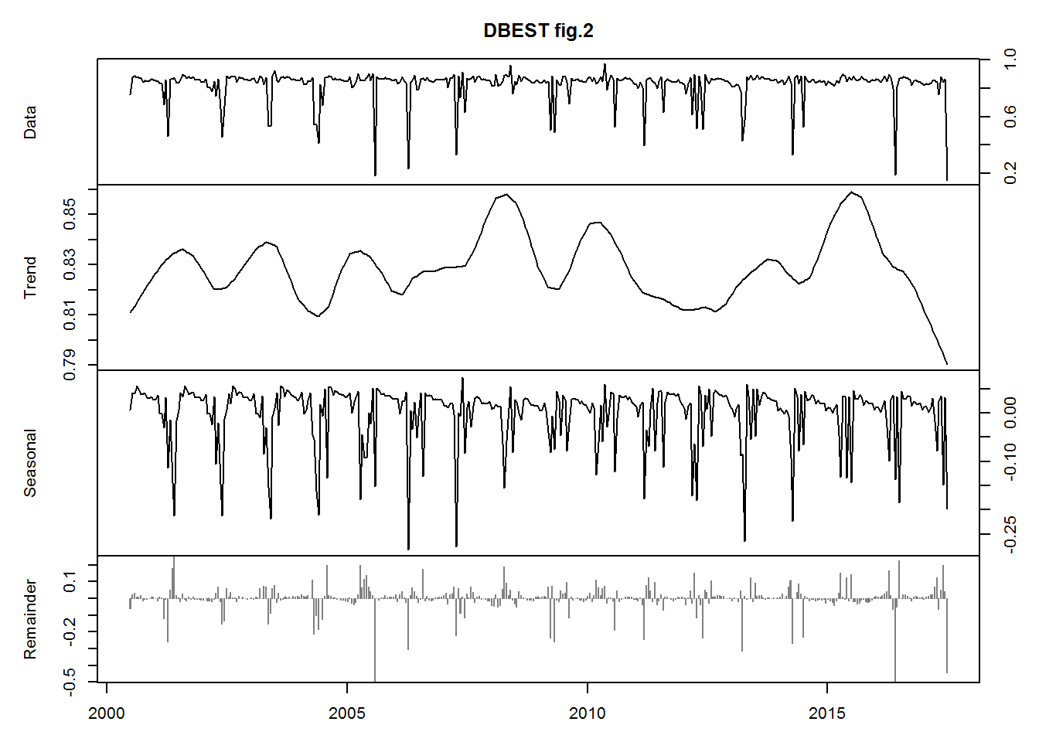

bb=bfast(ts[[95]], season = "harmonic", max.iter = 1)  
plot(bb, main="Pixel 6581: Pastagem-Soja e Milho")

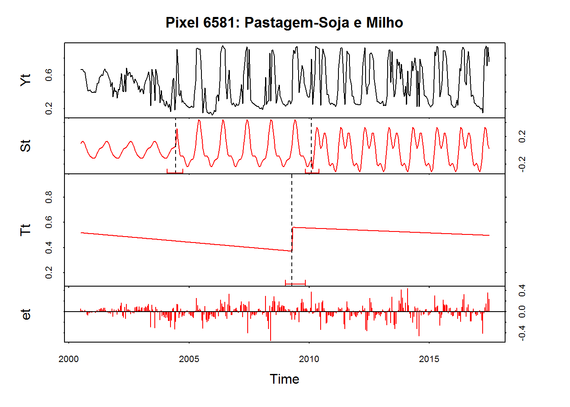

fs.nile <- Fstats(ts[[95]] ~ 1)  
plot(fs.nile)  
xx=breakpoints(fs.nile)  
n=length(xx$breakpoints)  
lines(breakpoints(fs.nile))

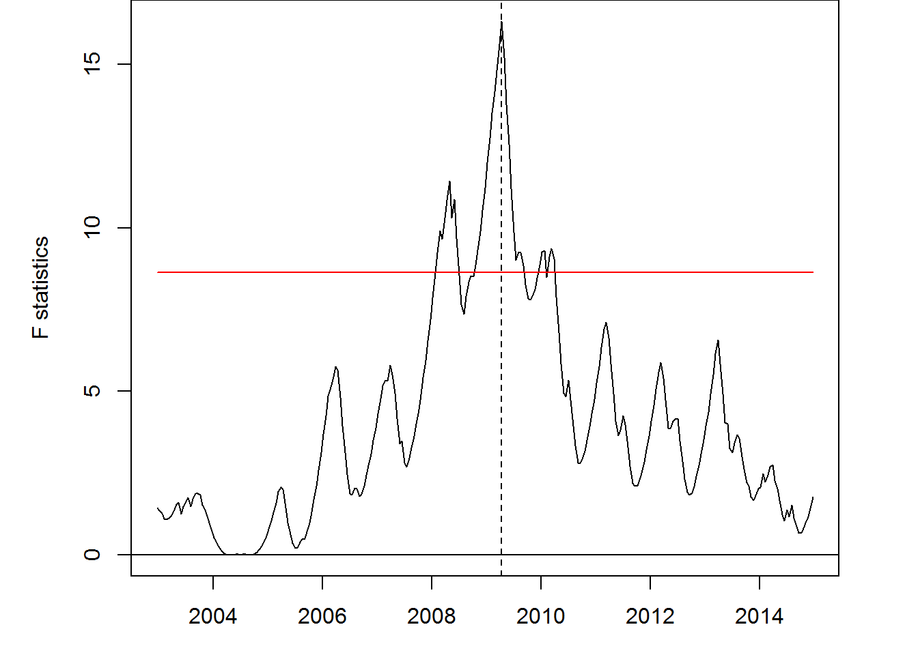

DBEST.Fig5a <- DBEST(data=ts[[95]], data.type="cyclical",   
 seasonality=23, algorithm="change detection",   
 breakpoints.no=n, first.level.shift=0.1,   
 second.level.shift=0.2, duration=24,   
 distance.threshold="default", alpha=0.05, plot="on")

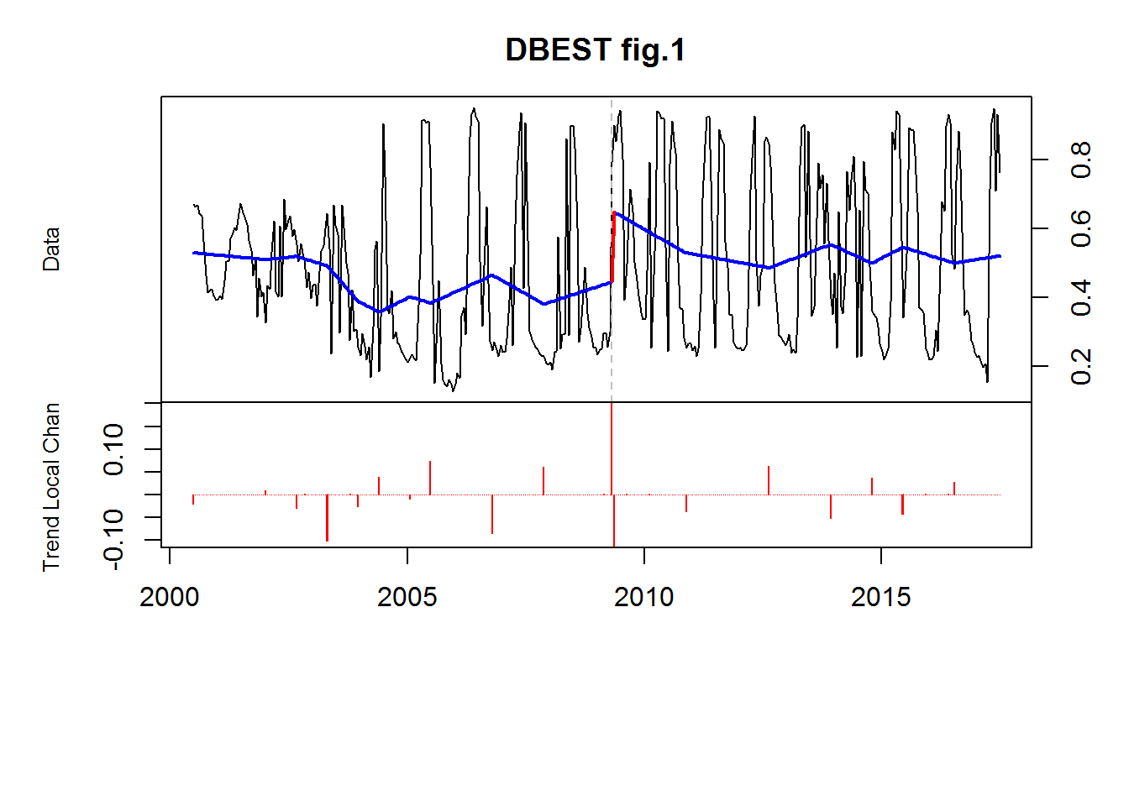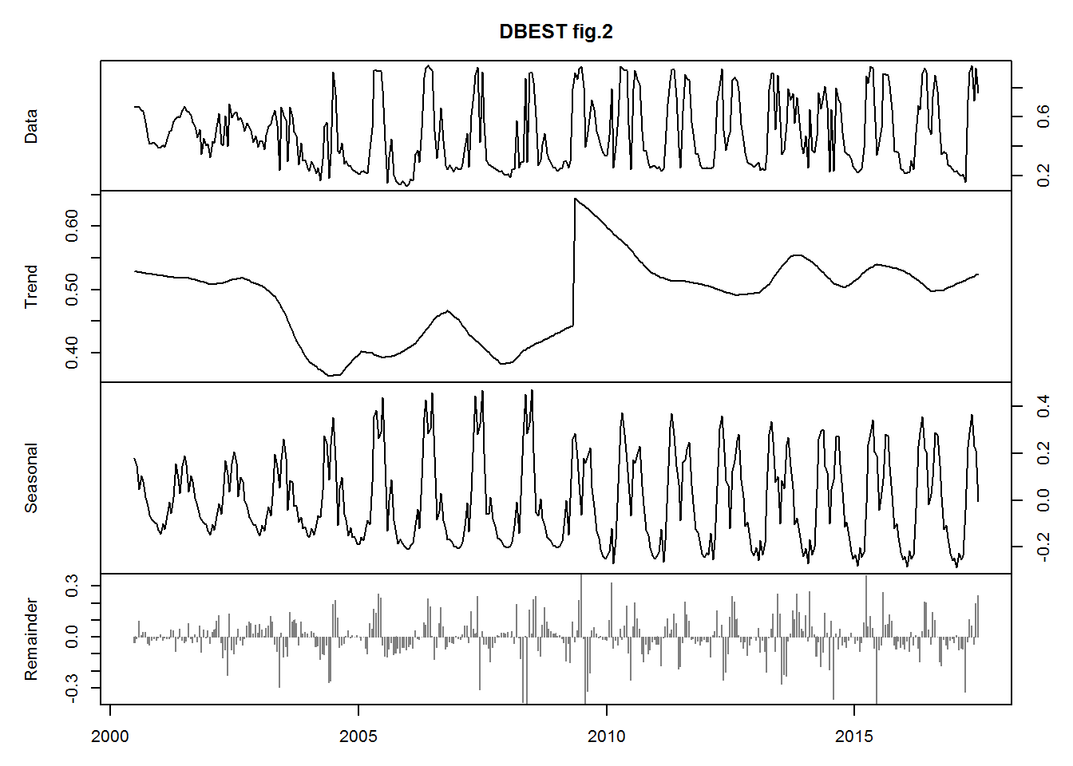

bb=bfast(ts[[32]], season = "harmonic", max.iter = 1)  
plot(bb, main="Pixel 20965: Pastagem-Soja")

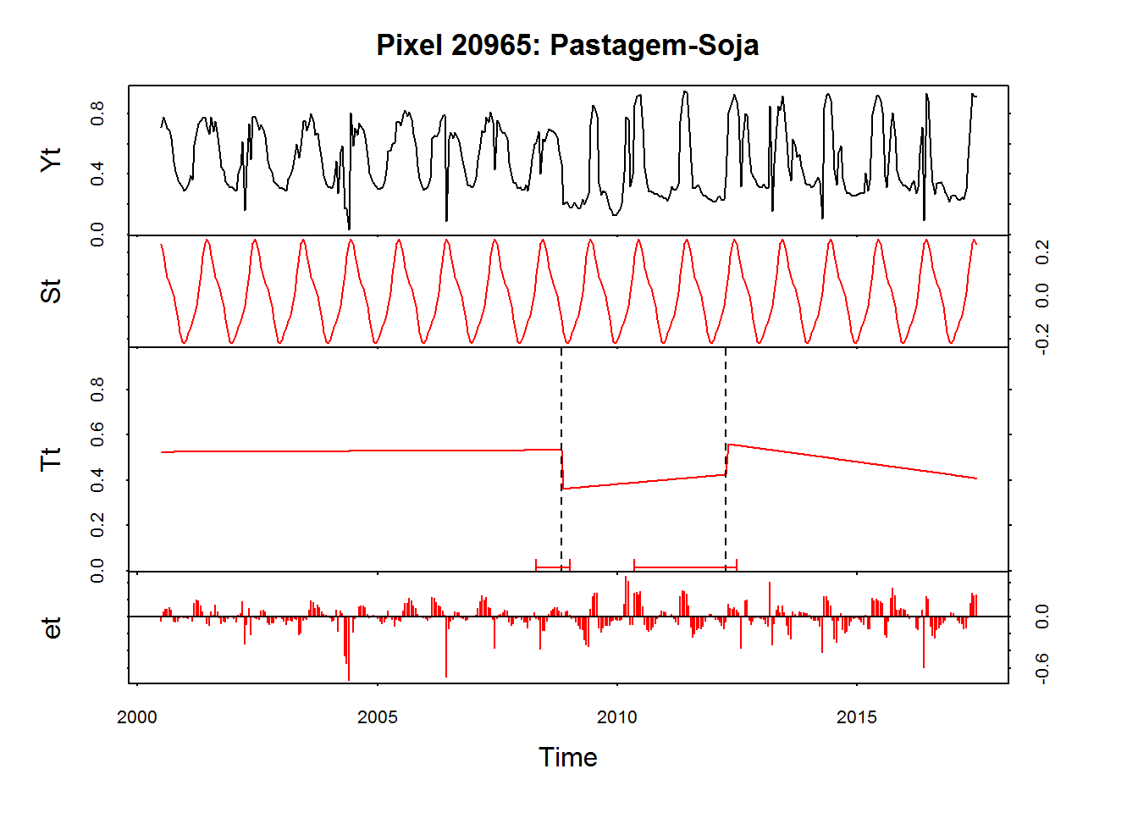

fs.nile <- Fstats(ts[[32]] ~ 1)  
plot(fs.nile)  
xx=breakpoints(fs.nile)  
n=length(xx$breakpoints)  
lines(breakpoints(fs.nile))

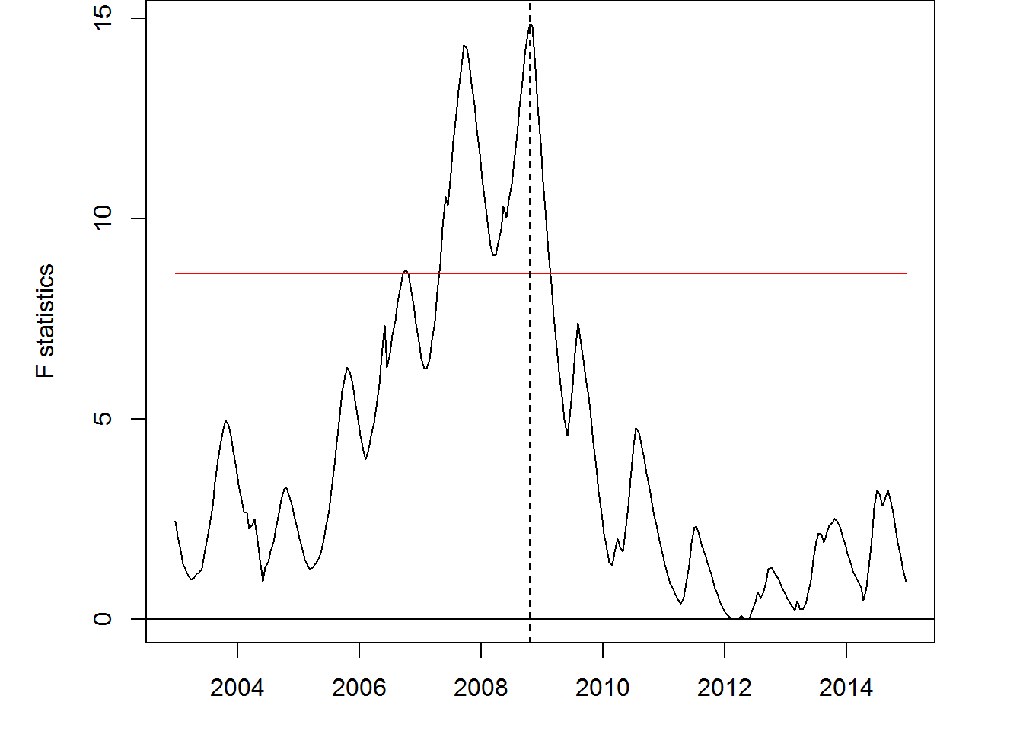

DBEST.Fig5a <- DBEST(data=ts[[32]], data.type="cyclical",   
 seasonality=23, algorithm="change detection",   
 breakpoints.no=n, first.level.shift=0.1,   
 second.level.shift=0.2, duration=24,   
 distance.threshold="default", alpha=0.05, plot="on")

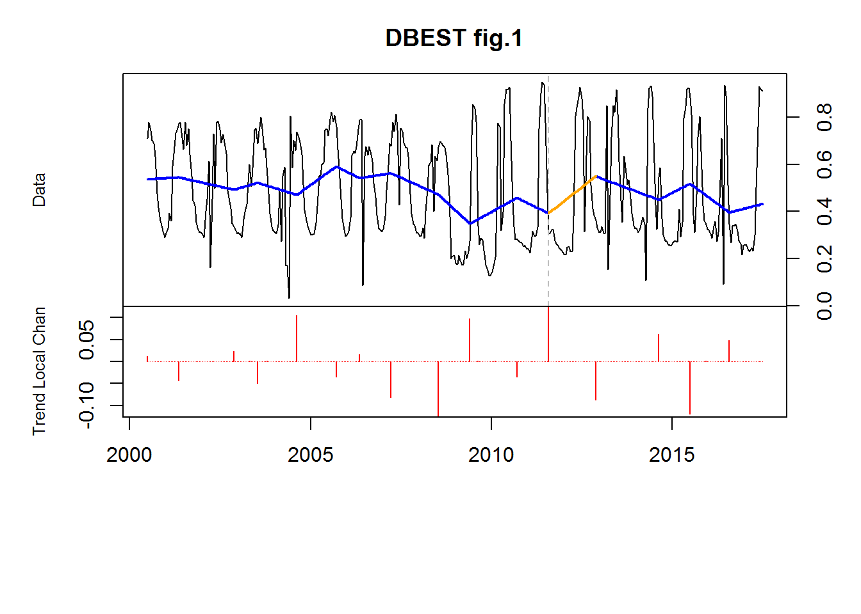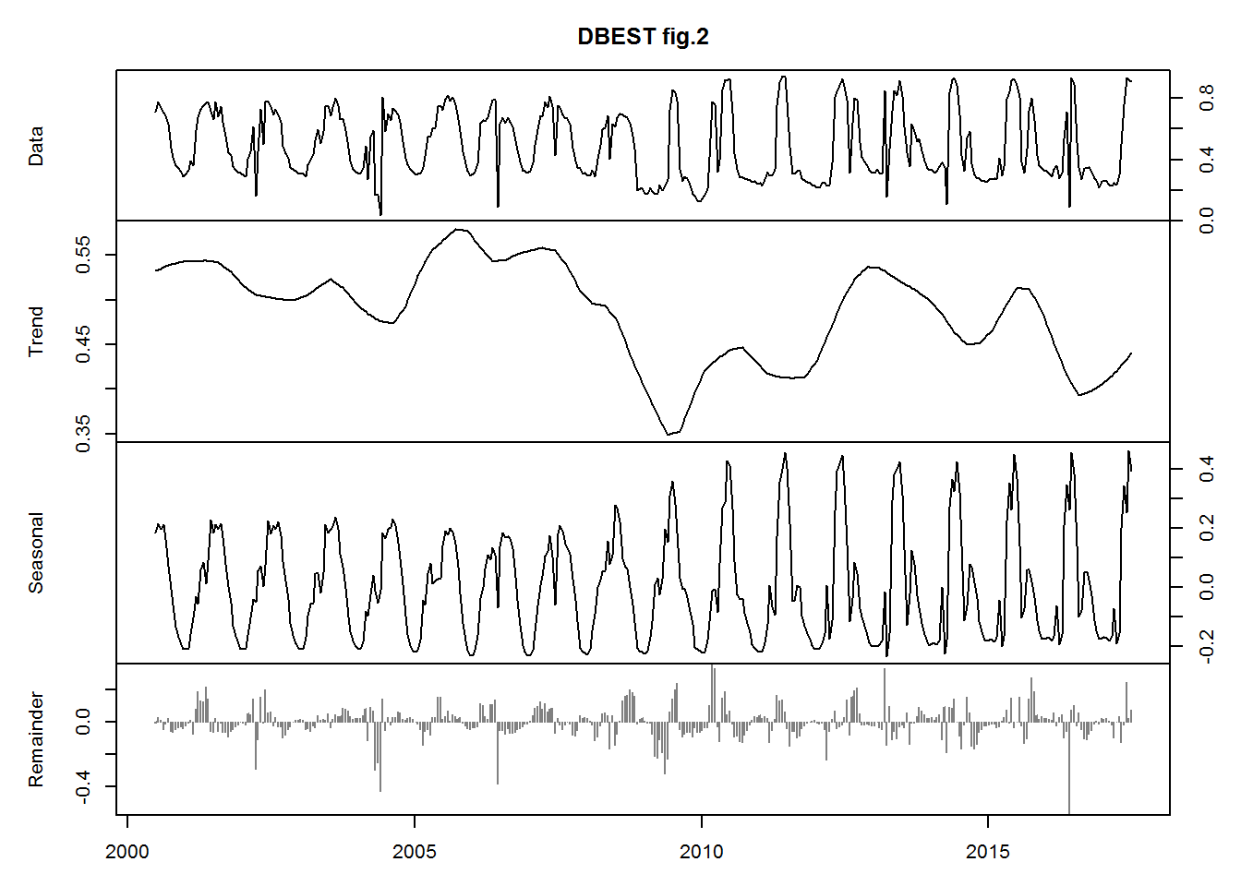

bb=bfast(ts[[50]], season = "harmonic", max.iter = 1)  
plot(bb, main="Pixel 23190: Eucalipto")

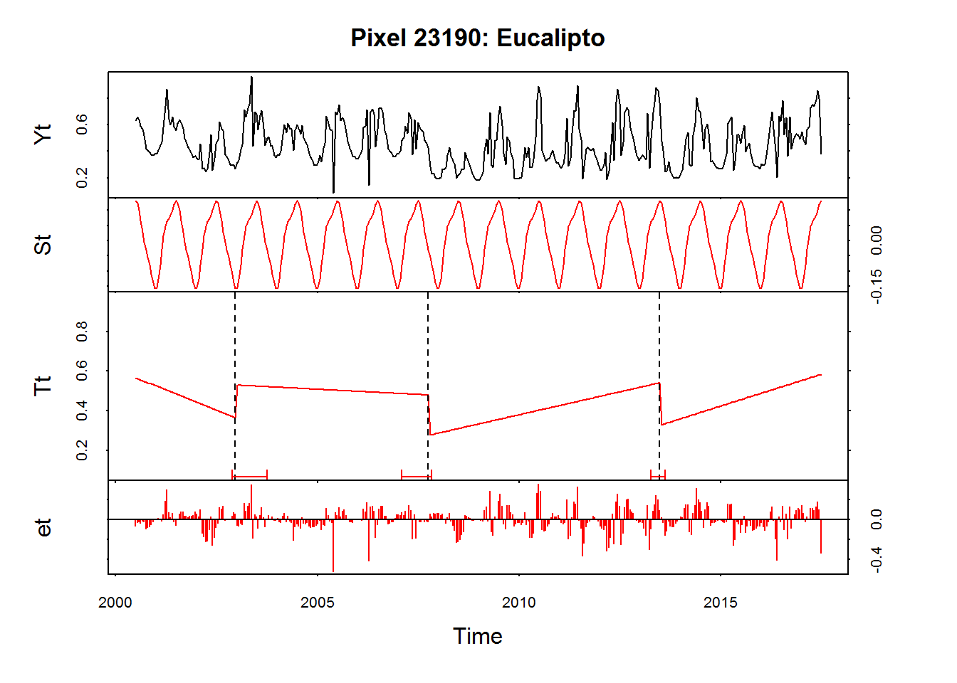

fs.nile <- Fstats(ts[[50]] ~ 1)  
plot(fs.nile)  
xx=breakpoints(fs.nile)  
n=length(xx$breakpoints)  
lines(breakpoints(fs.nile))

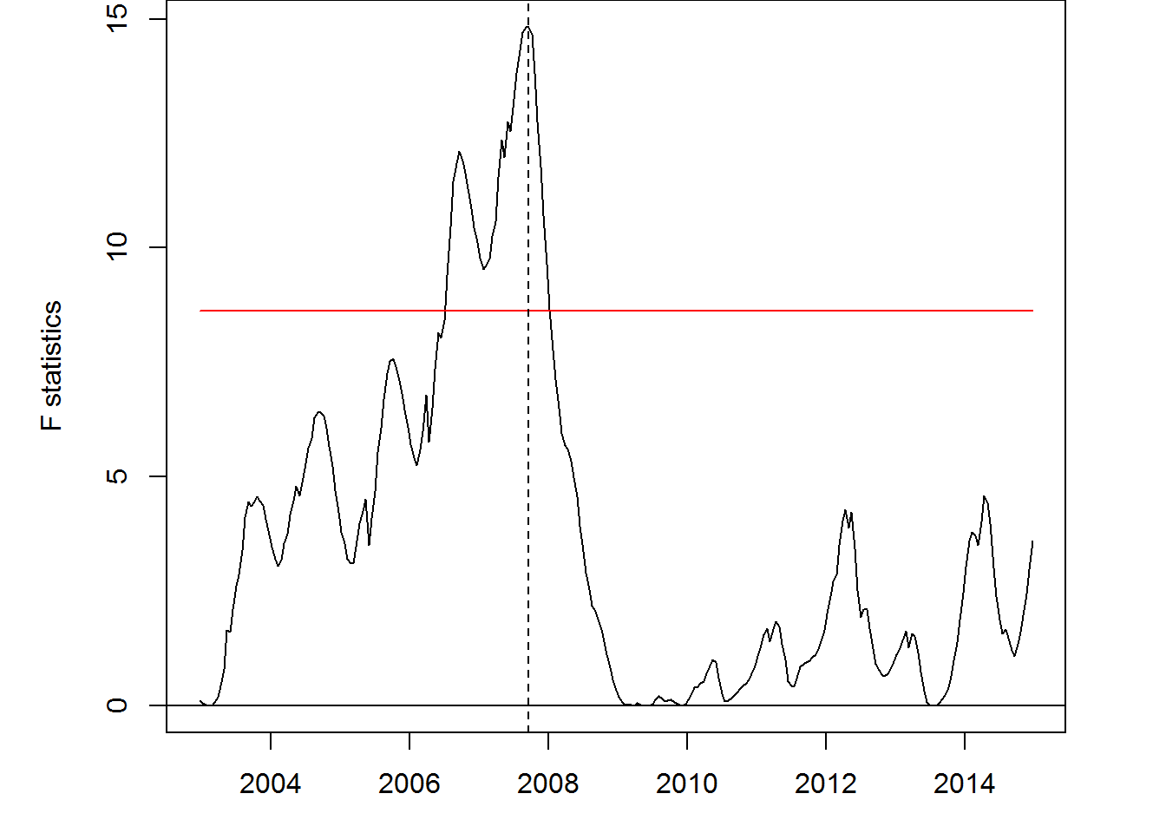

DBEST.Fig5a <- DBEST(data=ts[[50]], data.type="cyclical",   
 seasonality=23, algorithm="change detection",   
 breakpoints.no=n, first.level.shift=0.1,   
 second.level.shift=0.2, duration=24,   
 distance.threshold="default", alpha=0.05, plot="on")

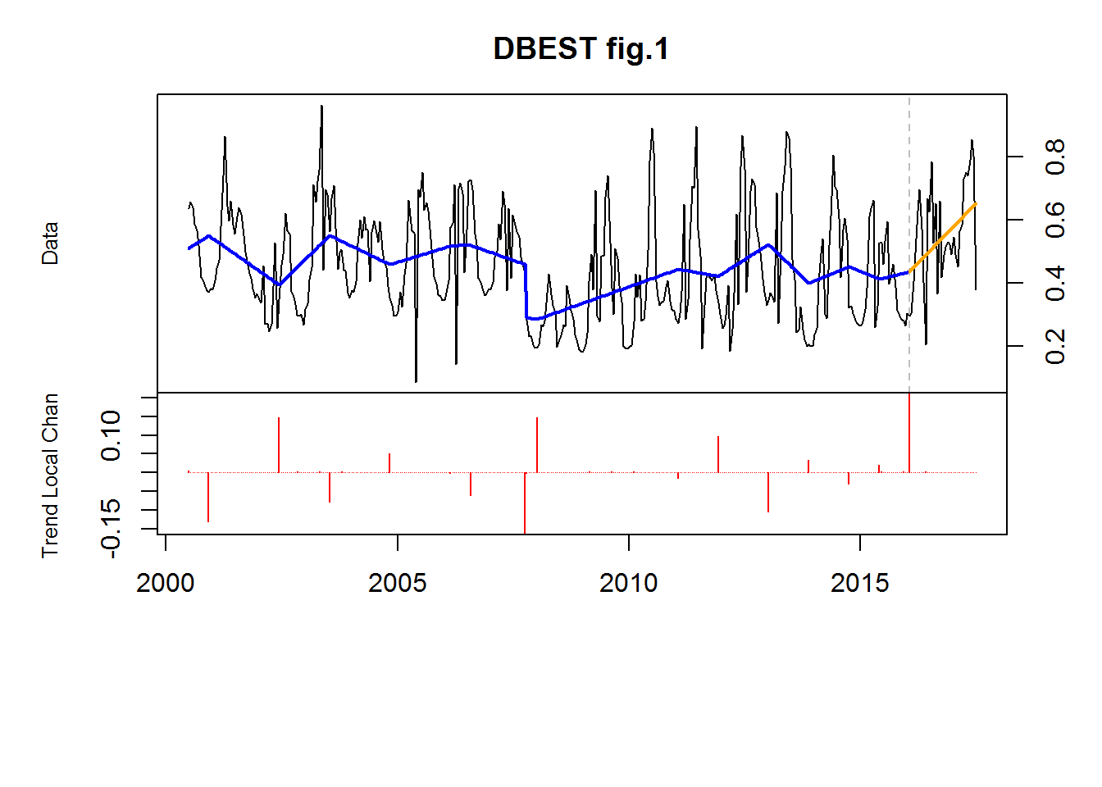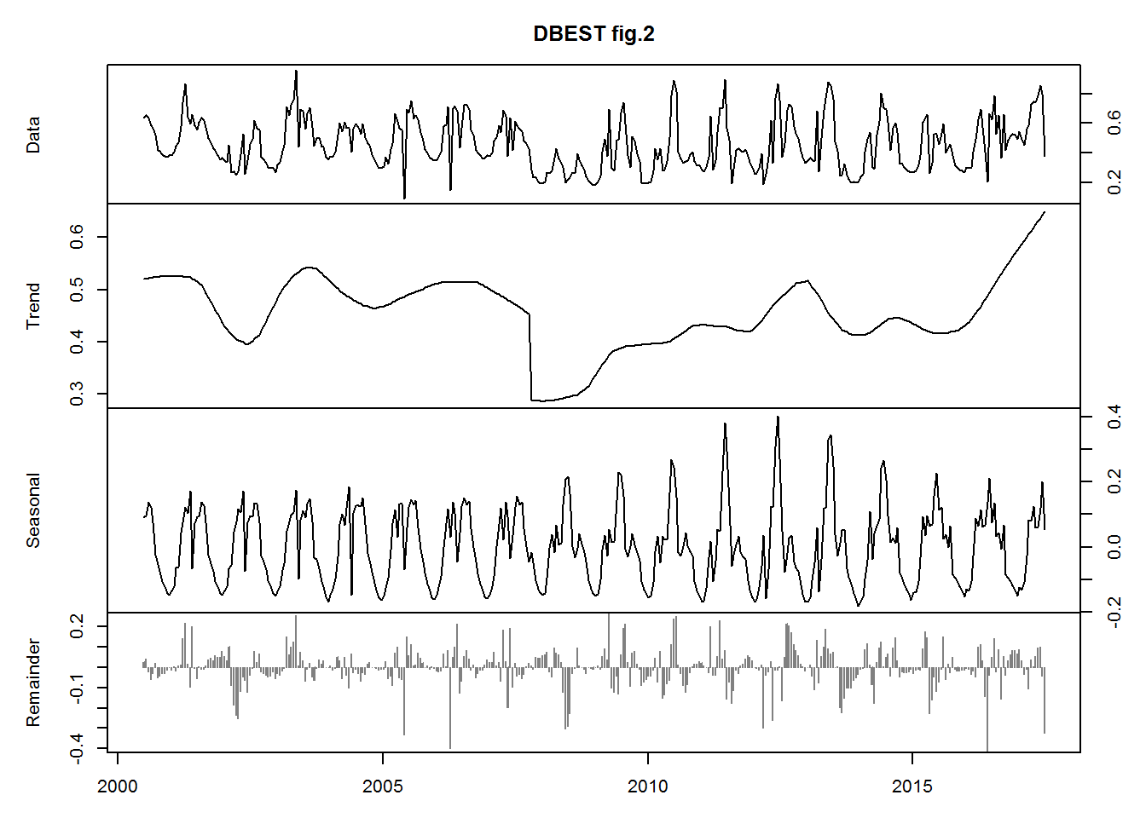

bb=bfast(ts[[5]], season = "harmonic", max.iter = 1)  
plot(bb, main="Pixel 11083: Seringa")



fs.nile <- Fstats(ts[[5]] ~ 1)  
plot(fs.nile)  
xx=breakpoints(fs.nile)  
n=length(xx$breakpoints)  
lines(breakpoints(fs.nile))

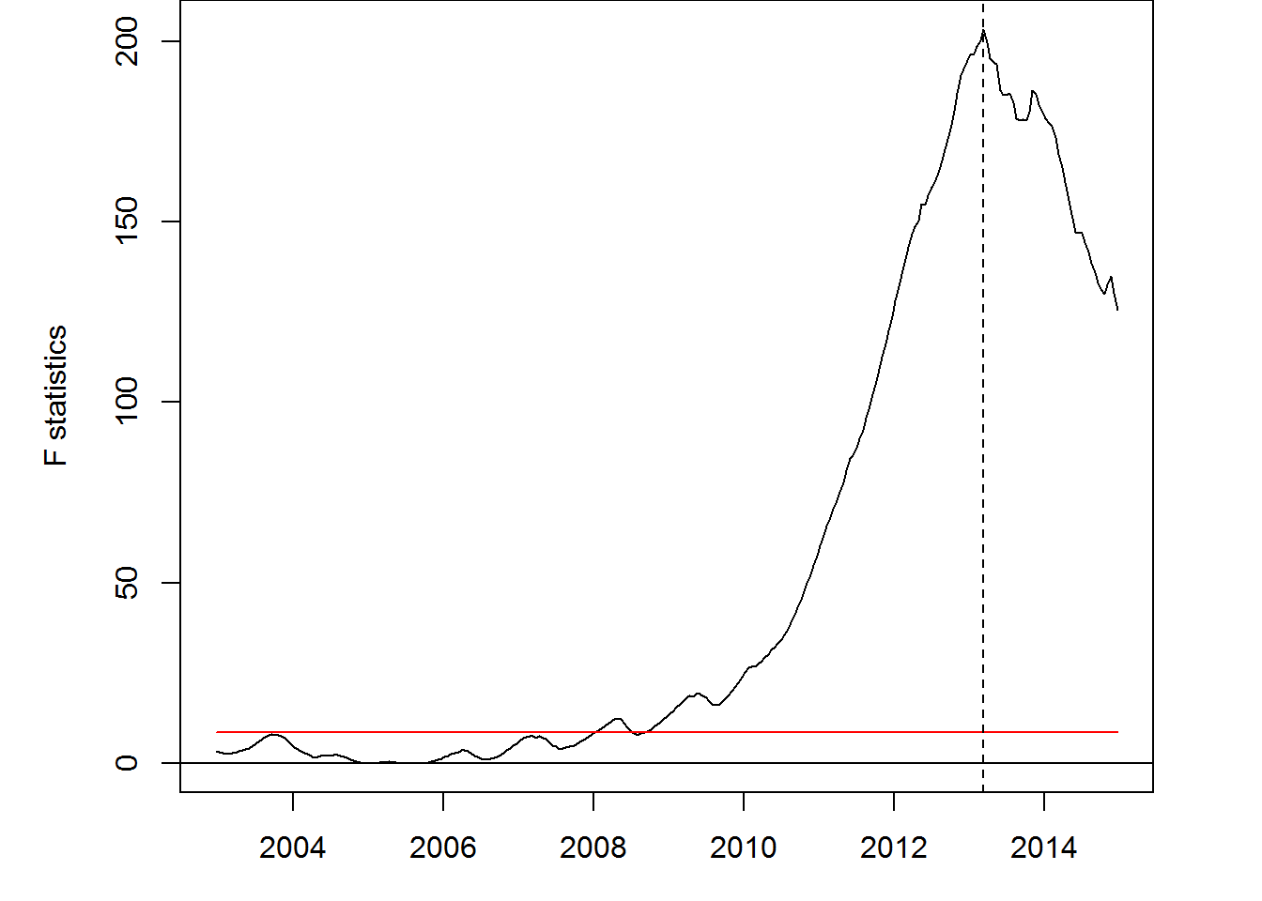

DBEST.Fig5a <- DBEST(data=ts[[5]], data.type="cyclical",   
 seasonality=23, algorithm="change detection",   
 breakpoints.no=n, first.level.shift=0.1,   
 second.level.shift=0.2, duration=24,   
 distance.threshold="default", alpha=0.05, plot="on")

